**LIQUIDS TABLE**

**RULES:**

1. **_NO_** liquids or food are allowed in this lab.
2. For the safety of our computers and network; ALL FOODS, LIQUIDS and WATER BOTTLES must be kept at this table **_ONLY_!**
3. **Anything without a sealable lid is to be thrown out immediately.**

Schedule:

At Lab opening ~ 8:00 am;

This desk will be cleaned, and wiped down for **convenience**.

Thirty minutes before lab closes;

**ALL remaining single use items will be trashed!!!**

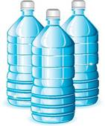

ONLY Reusable water bottles ***may be saved***, to be reclaimed the next day in Lost and Found.

Every few days, empty out and prepare for recycling of old bottles.